How to Use REDCap Mobile App

Purpose
The primary purpose of the REDCap Mobile App is offline data collection. It is NOT intended to be used by participants in order to take a survey. Your project must fit one of the following scenarios:
- It is a project that needs data collected when there is no internet access available.
- It is a project that needs data collected when there is sporadic internet access.

Mobile App Account Setup
Your first step is to download the REDCap Mobile App from the App Store or Google Play Store. When you first launch the REDCap mobile app, you must agree to the terms.

The next step is to create two users:
- Admin Account: This account will grant app function rights for data collectors which will allow them to setup/remove projects, send data, delete records, view/modify existing records and reset passwords. The admin account can also perform all of these functions with the exception of data collection. The admin account will not have any projects associated. The data collector passwords can be recovered via the admin account but the Admin password cannot be reset.
- Data Collection: Allows a user to setup/remove projects, send data, delete records and view/modify existing records. The user will have their normal login for the REDCap server and a separate unique login for the REDCap Mobile App.

Enable User Rights for Mobile App
Once you have set up your users, you can then set up your mobile project. To set up your project, open your project on the external REDCap and navigate to User Rights and grant Mobile App Rights.

Request Mobile App API Token
Log into REDCap and navigate to your project. Click on REDCap Mobile App and then click on Request API Token. An email will be sent to REDCap Support for approval and you will be notified via email when your request is approved.
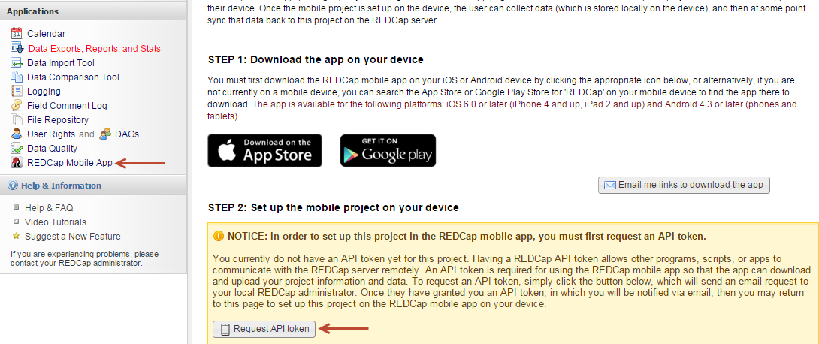

Set Up Mobile Project on Device
Launch the REDCap mobile app and log in as your data collection user (not the admin account) and click “Set Up Mobile Project”. Click “Scan QR code” from the REDCap Mobile App screen in your REDCap project and use your mobile device to scan the code. If you experience any issues you may click “Can’t get the QR code to work” and then enter the Initialization code in the code box on your mobile project.
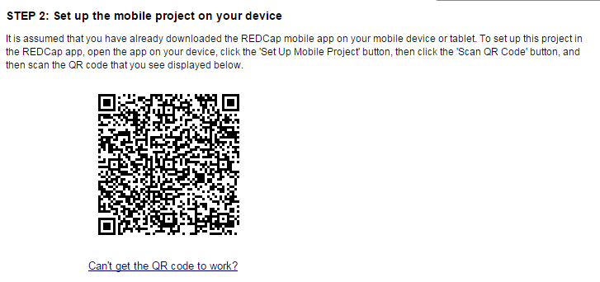
Click on the project name to confirm and to begin its download configuration. The download may take a few minutes depending on how large your project is. There are additional settings you may choose such as Download all records, get a partial set of data or do not download records.

Collect Data
To begin collecting data offline, click collect data. Select an instrument and then either click “Create New Record” or click on an existing record. Enter the data and then click Save Record or Save and Continue or Save and go to Next Instrument.
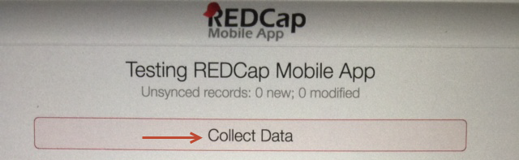
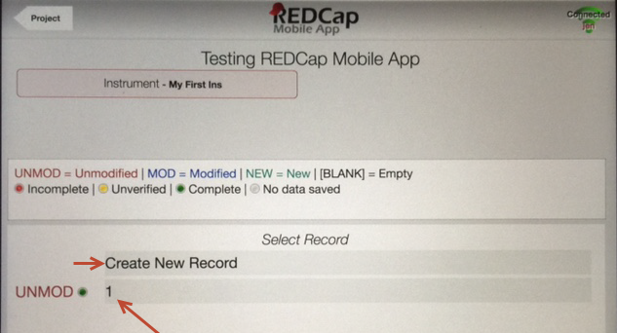

Check for Other Records on the Server
To check to see if there are records that exist in your project that do not exist on your mobile device, click “Check for other records on the server”.
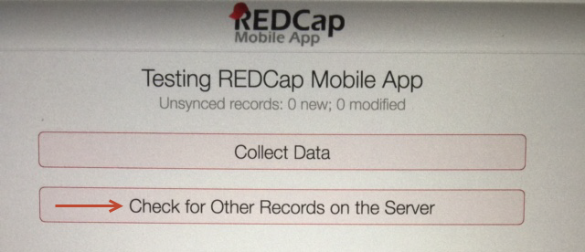

Send Data to Server
When you have an internet connect and you are ready to send your offline data to the REDCap server, click “Send Data to Server” and then click “Begin Send”. You will receive a message letting you know if your data was successfully sent to the REDCap server. Check your project on the REDCap server to ensure data was transferred correctly.
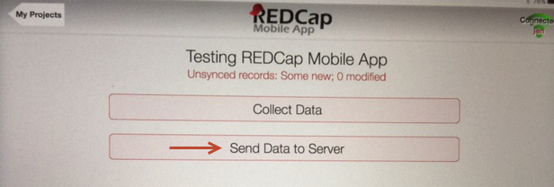

Refresh Setup & Data
If records exist in your project and you would like to sync them to your mobile device, click “Refresh Setup and Data”. This will delete your local copy of the project data and configurations as well as any offline data you have not transferred over to the project on the REDCap server. Be sure to transfer your offline data first! Once deleted, the mobile app will install the current version. There will be two messages asking you to confirm that you want to delete your data.
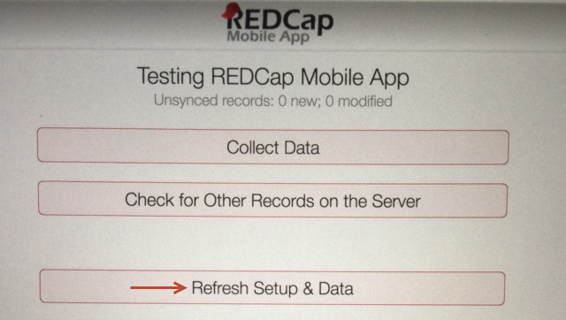

Project Admin
If you would like to delete the data from your Mobile Project, click “Clean All Project Data”. This will only delete the records on your Mobile App and will not affect your project on the REDCap server.
If you would like to remove the Mobile Project from your device, click on “Remove Mobile Project”. You will receive a message asking you to confirm that you want to delete the mobile project. This will not delete your project on the REDCap server.
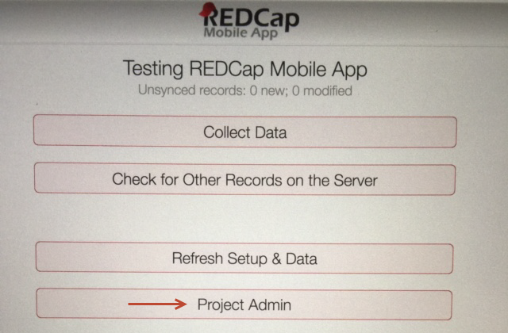

Send Emergency Data Dump
If your data was not transferred over successfully when you clicked “Send Data to Server”, you may send an emergency data dump. This should be used rarely and you must have an internet connection in order to use this functionality. The REDCap mobile app will send your data as a CSV file and it will be stored under the REDCap Mobile App section. To use this function, click “Send Emergency Data Dump” and then click “Proceed with Emergency Send”.
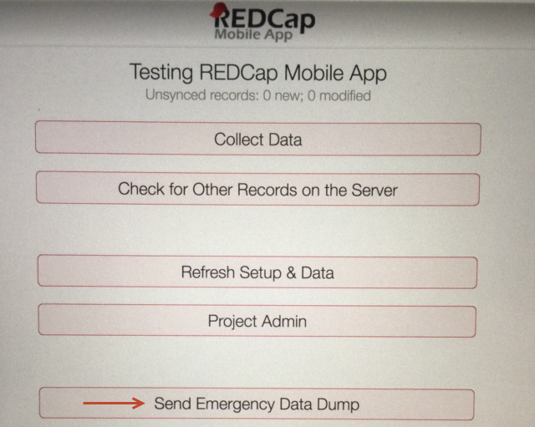
You will receive a message letting you know if your data dump was successful. Navigate to your project on the REDCap server and ensure the CSV file appears under the REDCap Mobile App section under the Mobile App File Archive tab.
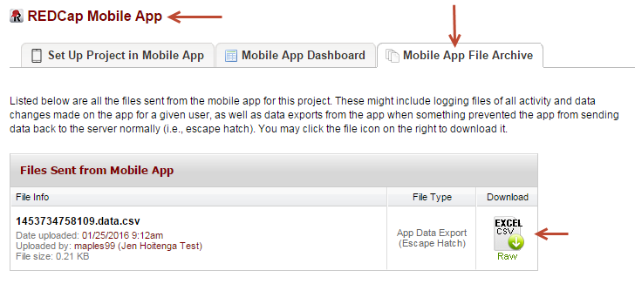
Click on the Excel CSV file and save it to your desktop. Click on the Data Import Tool and navigate to your CSV file and import your data.

Send Project Logs
If you would like to send the mobile app project log to the project on the REDCap server, click “Send Project Logs”. A text file will be sent and stored under the REDCap Mobile App section under the Mobile App File Archive.
